**Part 1: News App**

Created a login page with username and password.

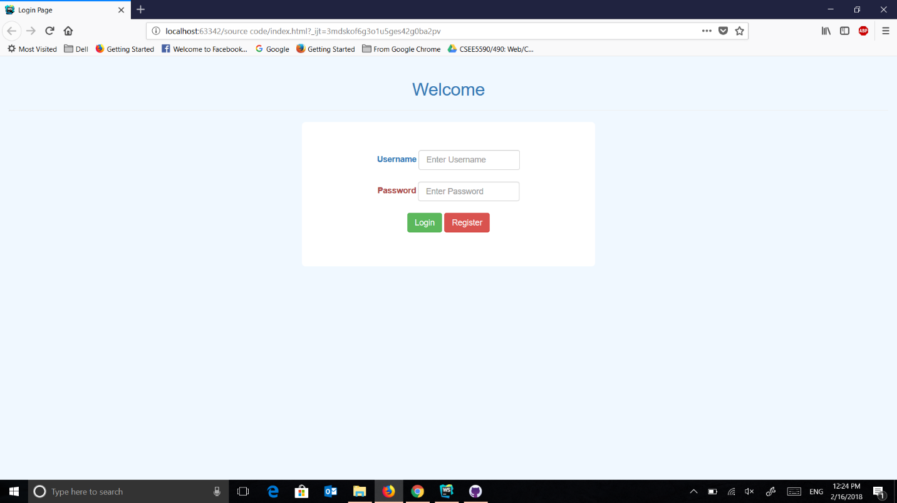

If username and password doesn't match, it will ask for registration

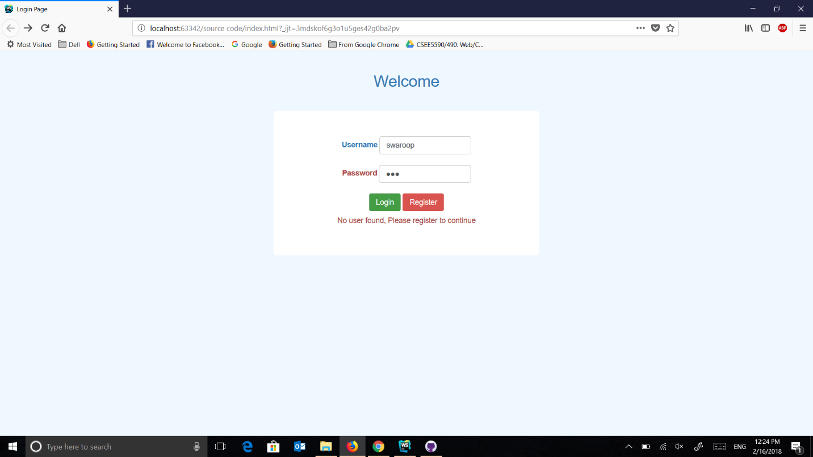

Registration Page

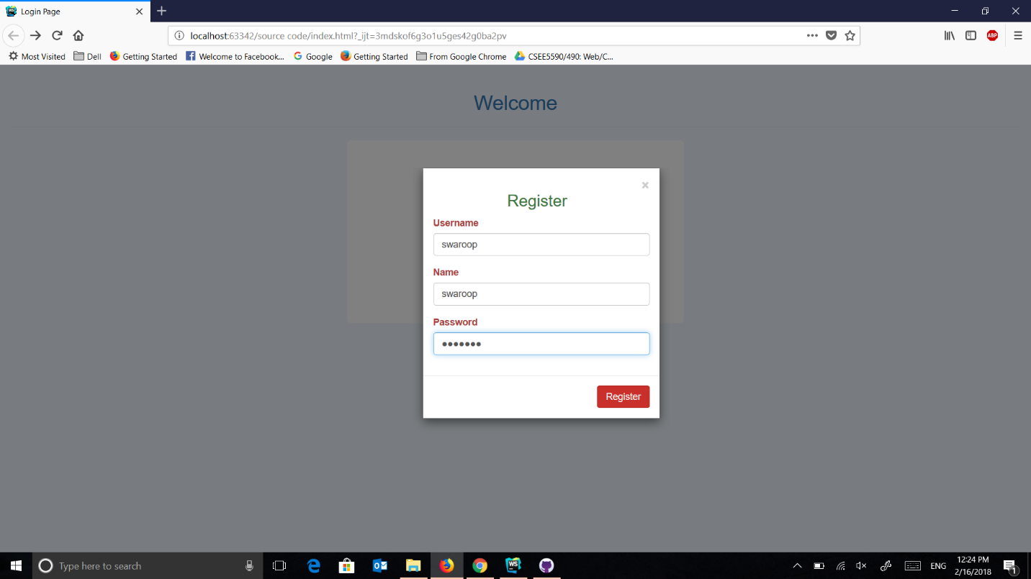

After Registration and signing in, it takes to the home page. which contains search bar to search a topic and dropdown for different news sources.

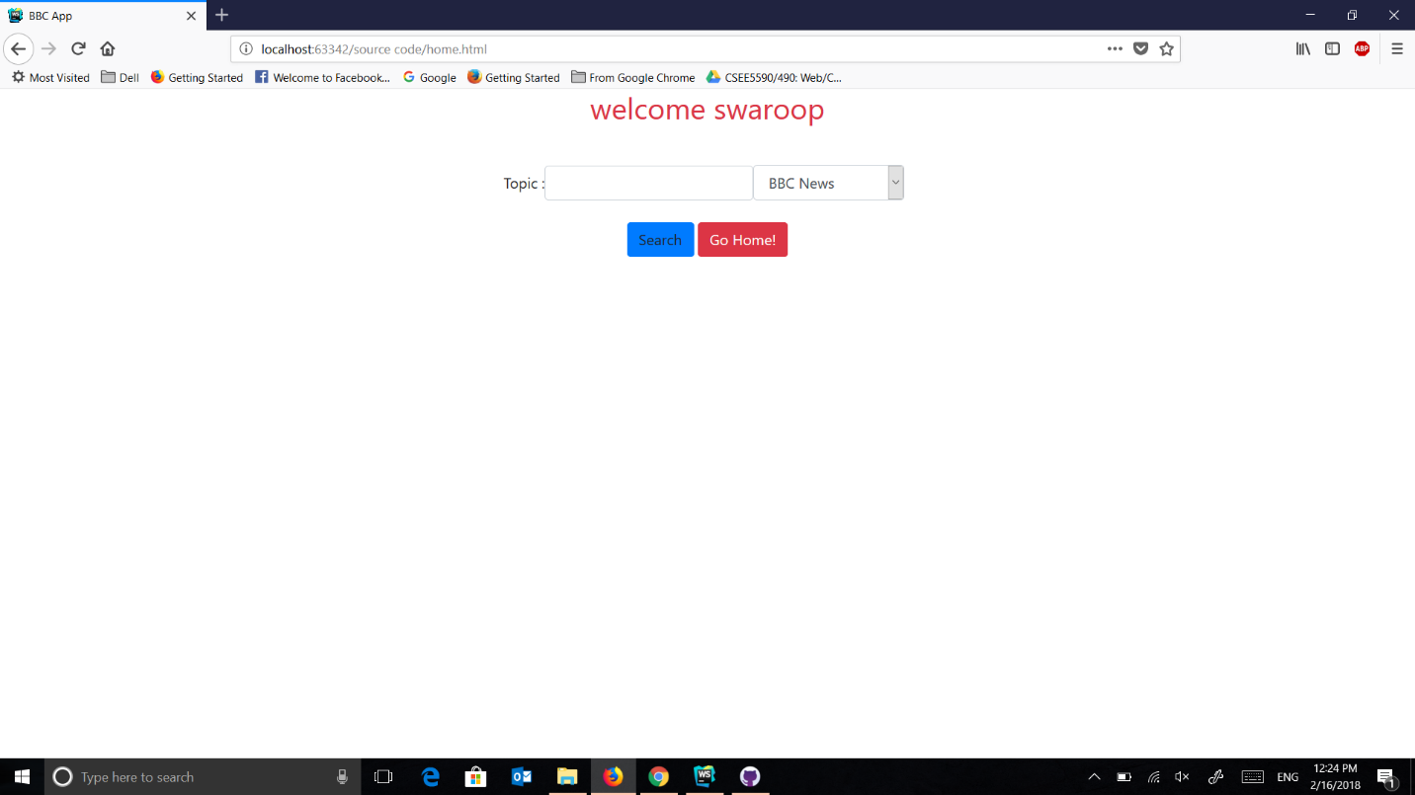

If we search without topic but with source, it will show the top news from the source

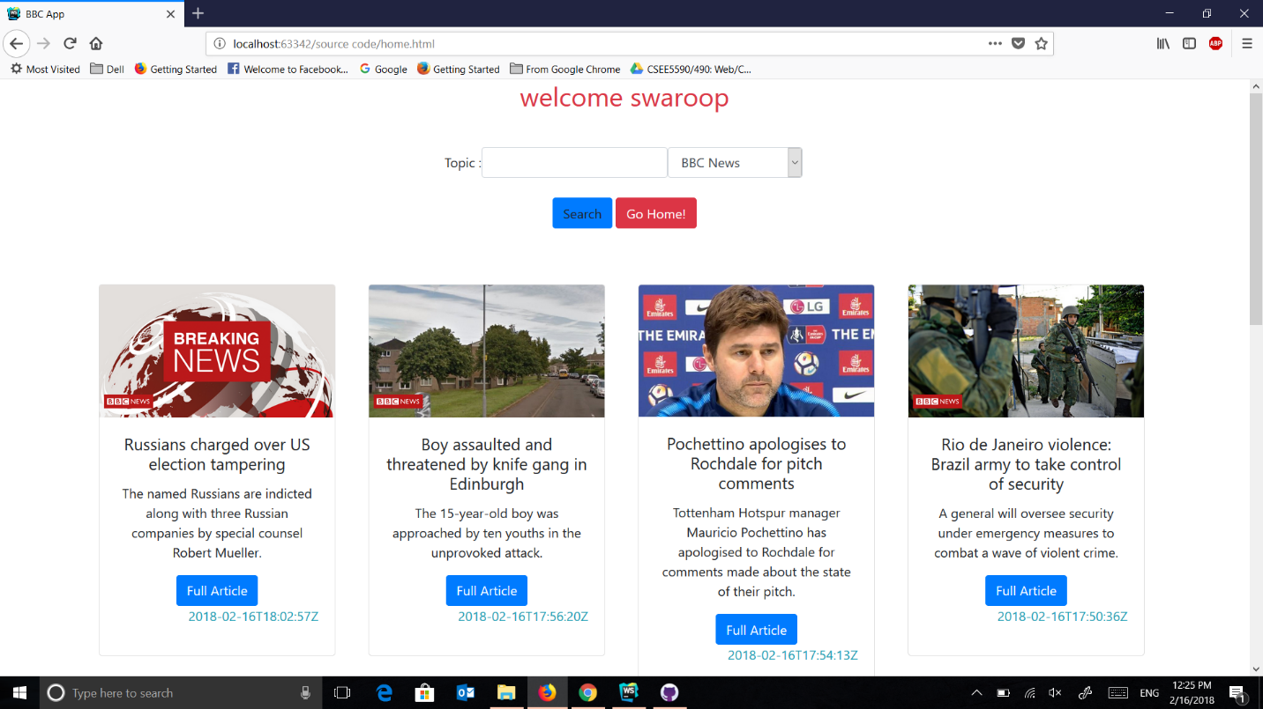

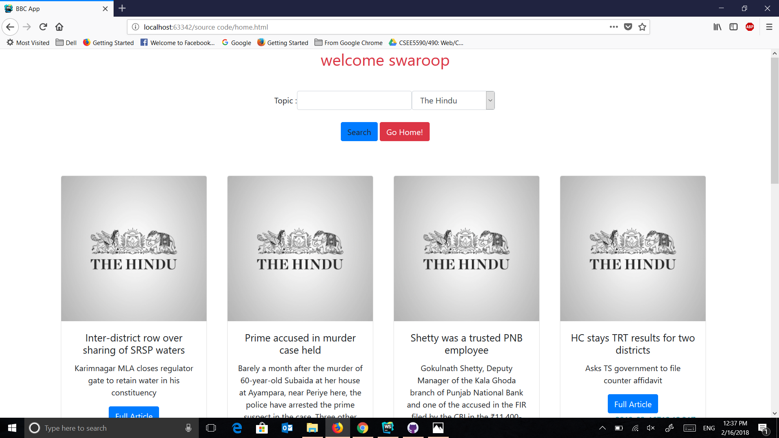

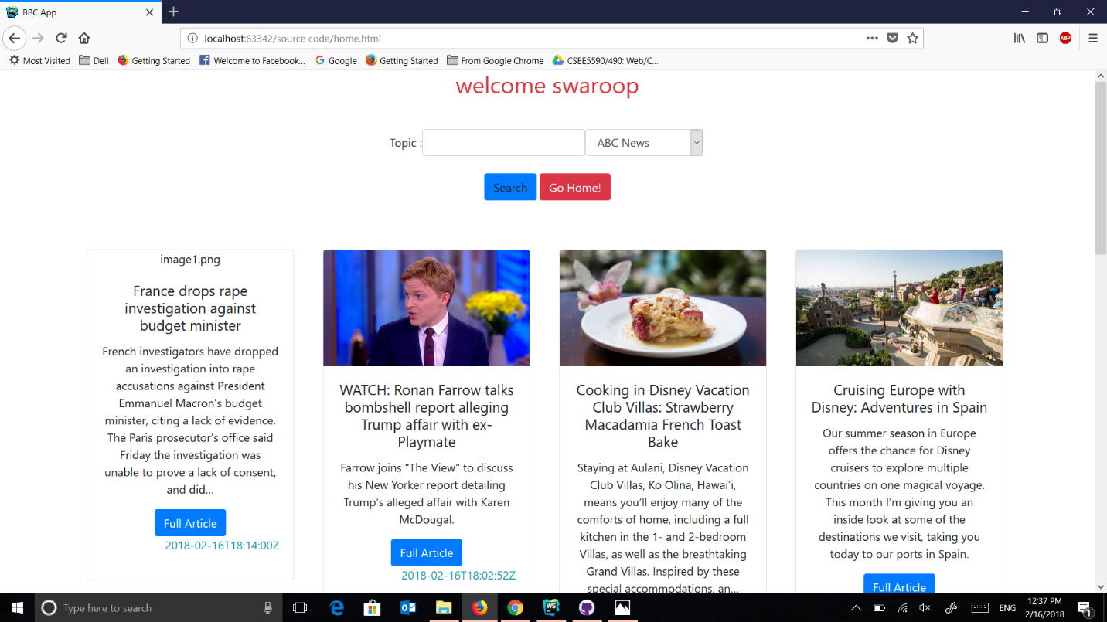

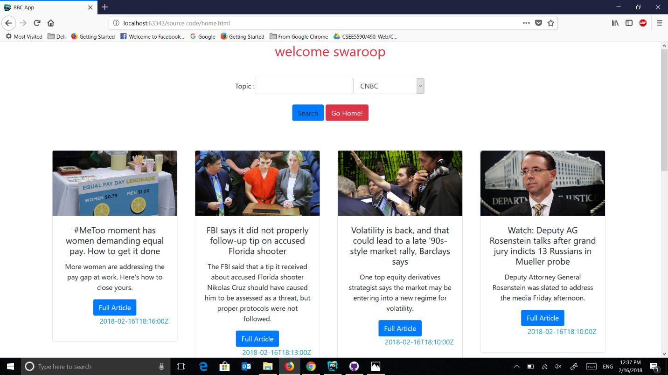

If you click on full article it open new tab with the full content of the article.

If we search for the topic and source

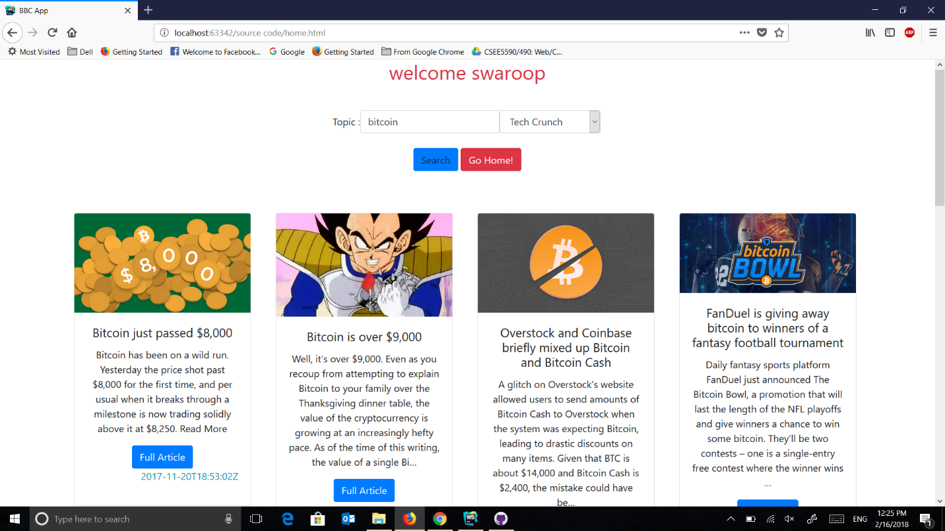

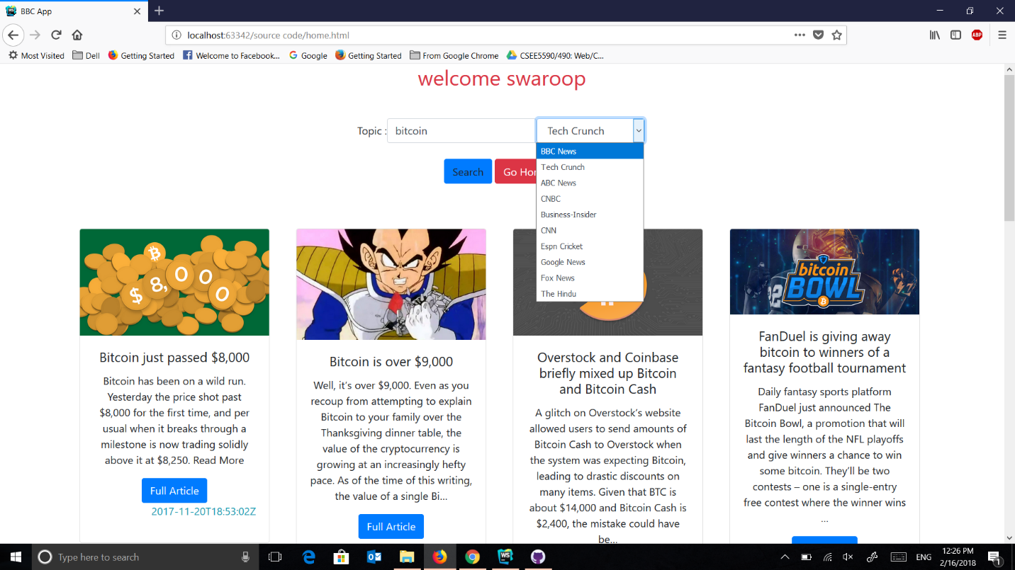

**Part 2: Tie-Toe Game**

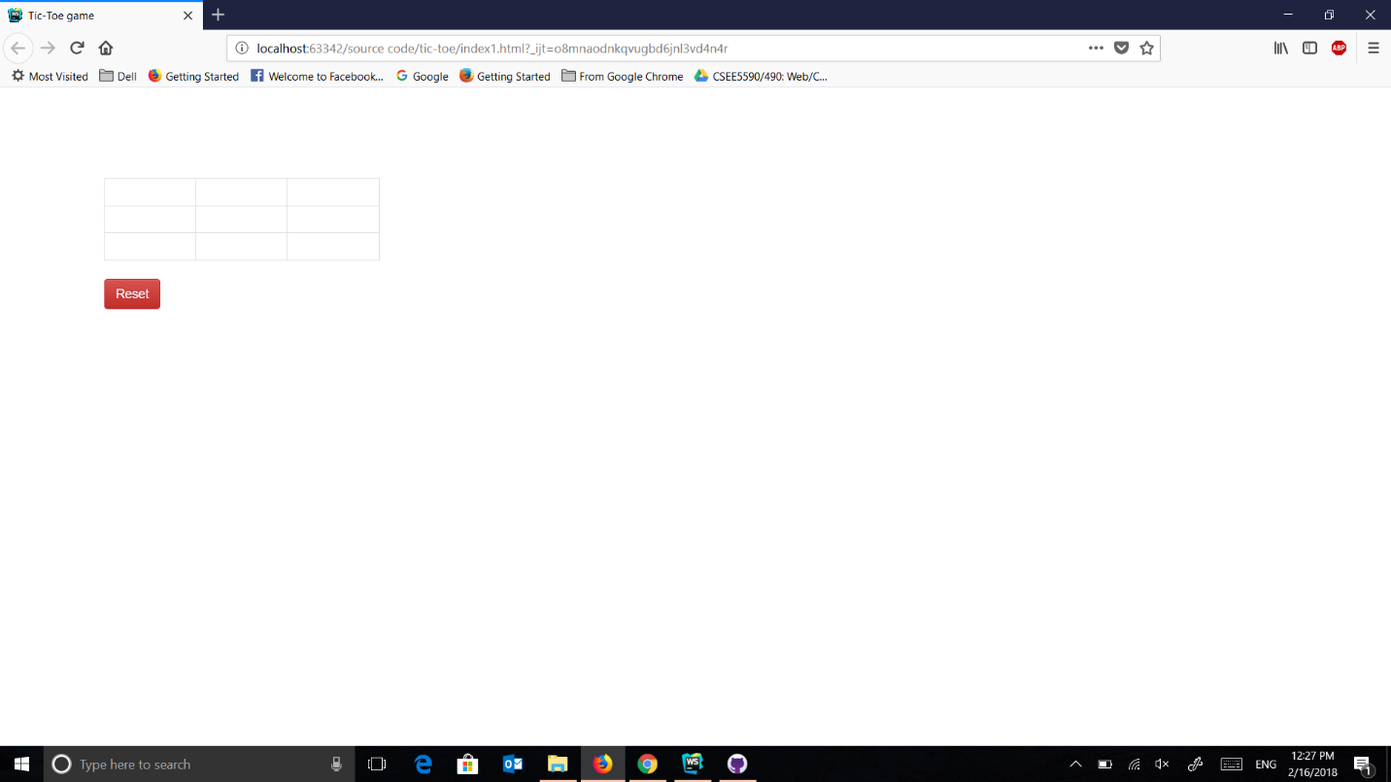

the first player is distinguished by X and the second player by O

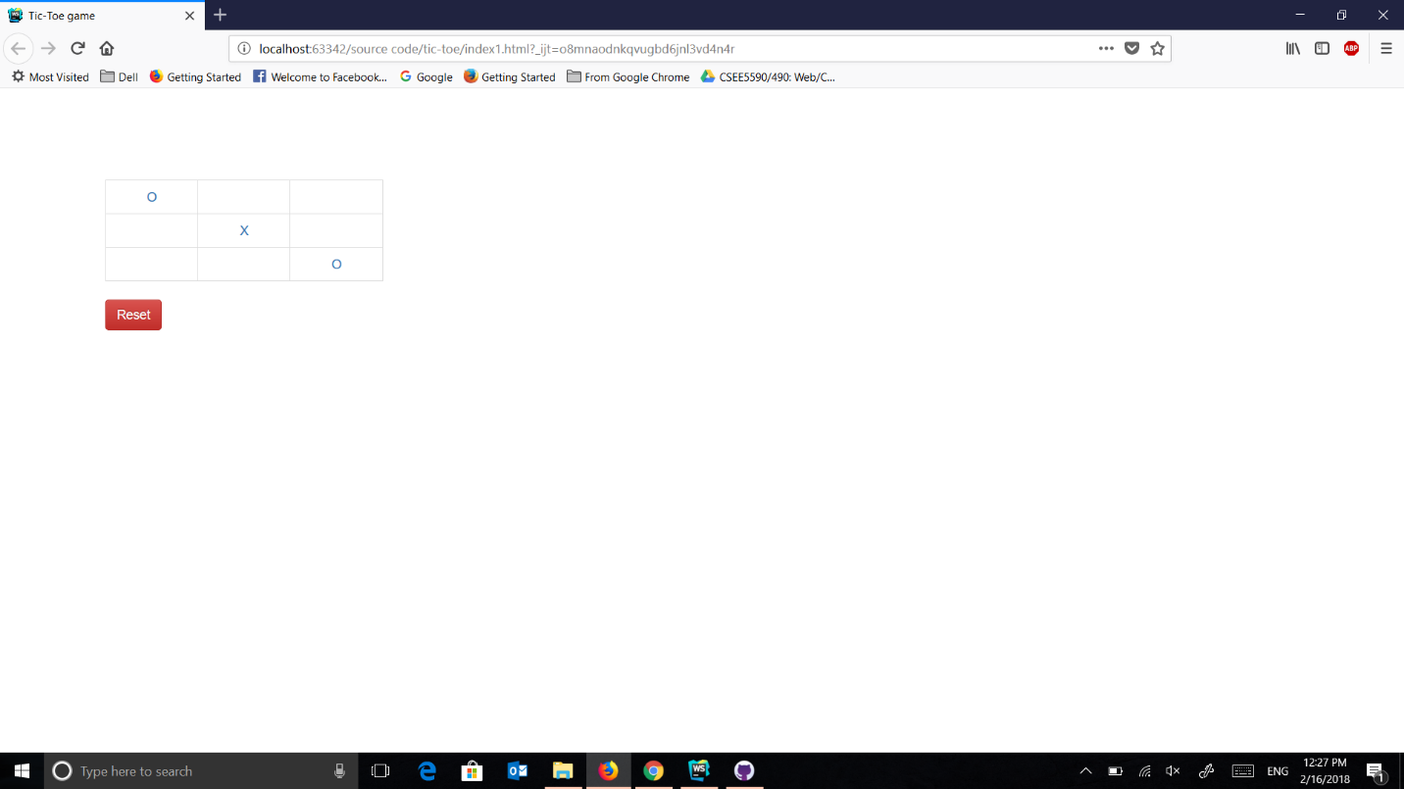

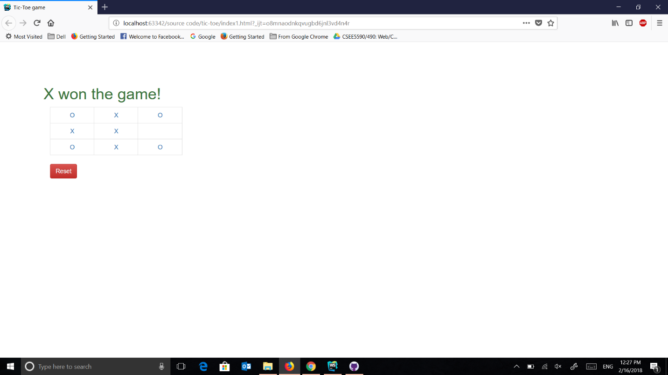

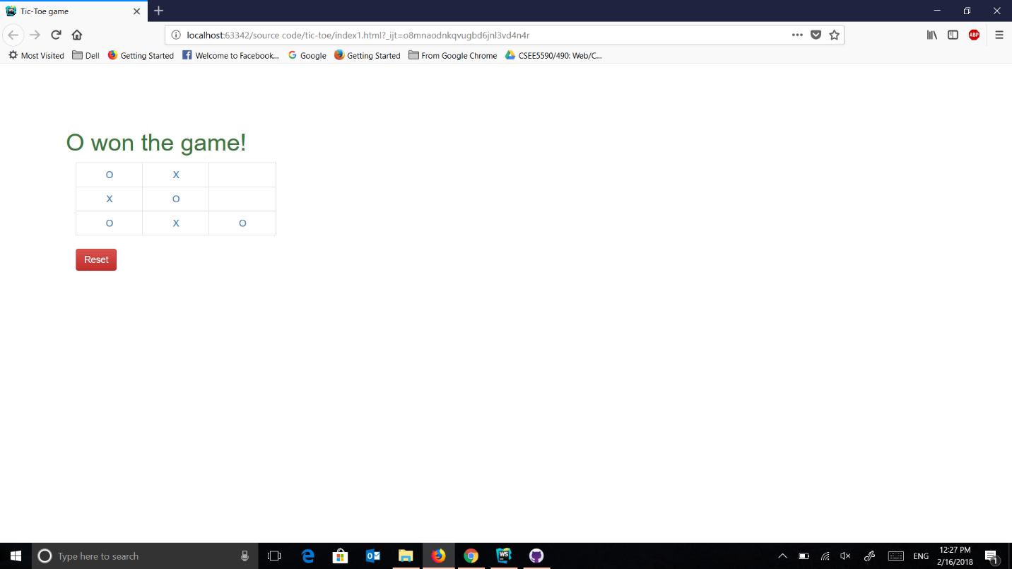

**Code Snippet:**

**var *loginid*** = ***localStorage***.getItem(**"resid"**);  
***console***.log(***loginid***);  
$(**"#page"**).text( **"welcome "** +***loginid***);  
  
  
**function** *respone*(source,topic) {  
  
 **var** xhhtp = **new *XMLHttpRequest***();  
 xhhtp.open(**'GET'**,**"https://newsapi.org/v2/everything?q="**+topic+**"&sources="**+source+**"&apiKey=b5468b9937314c37ae472c8d30430664"**, **false**);  
 xhhtp.send();  
 **return** xhhtp;  
}  
  
**function** *showdata*(news) {  
  
 ***console***.log(news.articles);  
 $(**"#card1"**).show();  
 $(**"#news1"**).text(news.articles[0].title);  
 $(**"#news11"**).text(news.articles[0].description);  
 $(**"#news111"**).attr(**"href"**,news.articles[0].**url**);  
 $(**"#image1"**).attr(**"src"**,news.articles[0].urlToImage);  
 $(**"#time1"**).text(news.articles[0].publishedAt);  
 $(**"#card2"**).show();  
 $(**"#news2"**).text(news.articles[1].title);  
 $(**"#news21"**).text(news.articles[1].description);  
 $(**"#news211"**).attr(**"href"**,news.articles[1].**url**);  
 $(**"#image2"**).attr(**"src"**,news.articles[1].urlToImage);  
 $(**"#time2"**).text(news.articles[1].publishedAt);  
 $(**"#card3"**).show();  
 $(**"#news3"**).text(news.articles[2].title);  
 $(**"#news31"**).text(news.articles[2].description);  
 $(**"#news311"**).attr(**"href"**,news.articles[2].**url**);  
 $(**"#image3"**).attr(**"src"**,news.articles[2].urlToImage);  
 $(**"#time3"**).text(news.articles[2].publishedAt);  
 $(**"#card4"**).show();  
 $(**"#news4"**).text(news.articles[3].title);  
 $(**"#news41"**).text(news.articles[3].description);  
 $(**"#news411"**).attr(**"href"**,news.articles[3].**url**);  
 $(**"#image4"**).attr(**"src"**,news.articles[3].urlToImage);  
 $(**"#time4"**).text(news.articles[3].publishedAt);  
 $(**"#card5"**).show();  
 $(**"#news5"**).text(news.articles[4].title);  
 $(**"#news51"**).text(news.articles[4].description);  
 $(**"#news511"**).attr(**"href"**,news.articles[4].**url**);  
 $(**"#image5"**).attr(**"src"**,news.articles[4].urlToImage);  
 $(**"#time5"**).text(news.articles[4].publishedAt);  
 $(**"#card6"**).show();  
 $(**"#news6"**).text(news.articles[5].title);  
 $(**"#news61"**).text(news.articles[5].description);  
 $(**"#news611"**).attr(**"href"**,news.articles[5].**url**);  
 $(**"#image6"**).attr(**"src"**,news.articles[5].urlToImage);  
 $(**"#time6"**).text(news.articles[5].publishedAt);  
 $(**"#card7"**).show();  
 $(**"#news7"**).text(news.articles[6].title);  
 $(**"#news71"**).text(news.articles[6].description);  
 $(**"#news711"**).attr(**"href"**,news.articles[6].**url**);  
 $(**"#image7"**).attr(**"src"**,news.articles[6].urlToImage);  
 $(**"#time7"**).text(news.articles[6].publishedAt);  
 $(**"#card8"**).show();

$(**"#news8"**).text(news.articles[7].title);  
 $(**"#news81"**).text(news.articles[7].description);  
 $(**"#news811"**).attr(**"href"**,news.articles[7].**url**);  
 $(**"#image8"**).attr(**"src"**,news.articles[7].urlToImage);  
 $(**"#time8"**).text(news.articles[7].publishedAt);  
}  
  
$(***document***).ready(**function** () {  
  
 $(**"#search"**).click(**function** () {  
  
 **topic** = $(**"#topic"**).val();  
 **source**= $(**"#source"**).val();  
 ***console***.log(**source**);  
 ***console***.log(**topic**);  
 **resp** = *respone*(**source**,**topic**);  
 **if** (**resp**.status == 200){  
 *showdata*(***JSON***.parse(**resp**.responseText));  
 ***console***.log(**"success"**);  
 }**else**{  
 ***console***.log(**"not find"**);  
  
 } })});